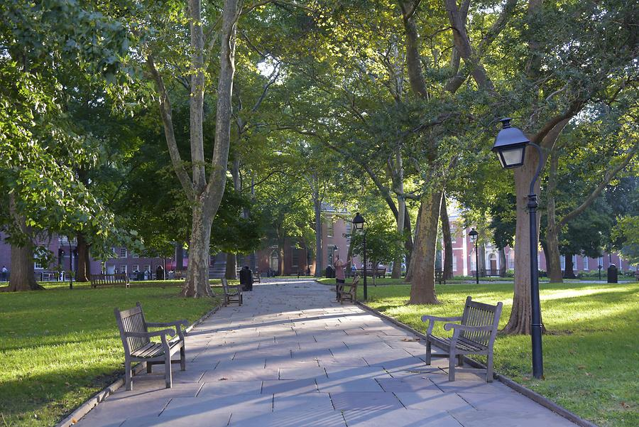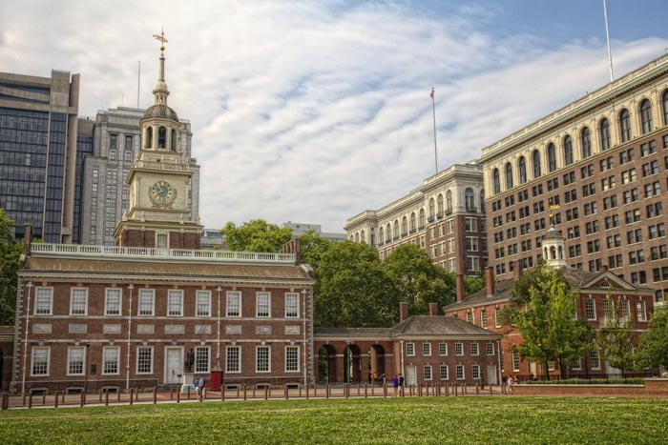

# Independence National Historical Park

**Independence National Historical Park** is a [federally protected historic district](https://en.wikipedia.org/wiki/List_of_the_United_States_National_Park_System_official_units) in [Philadelphia](https://en.wikipedia.org/wiki/Philadelphia), [Pennsylvania](https://en.wikipedia.org/wiki/Pennsylvania) that preserves several sites associated with the [American Revolution](https://en.wikipedia.org/wiki/American_Revolution) and the nation's founding history. Administered by the [National Park Service](https://en.wikipedia.org/wiki/National_Park_Service), the 55-acre (22 ha)[[1]](https://en.wikipedia.org/wiki/Independence_National_Historical_Park#cite_note-BP-1) park comprises many of Philadelphia's most-visited historic sites within the [Old City](https://en.wikipedia.org/wiki/Old_City,_Philadelphia) and [Society Hill](https://en.wikipedia.org/wiki/Society_Hill) neighborhoods. The park has been nicknamed "America's most historic square mile" because of its abundance of historic landmarks.[[3]](https://en.wikipedia.org/wiki/Independence_National_Historical_Park#cite_note-3)[[4]](https://en.wikipedia.org/wiki/Independence_National_Historical_Park#cite_note-4)[[5]](https://en.wikipedia.org/wiki/Independence_National_Historical_Park#cite_note-5)

The centerpiece of the park is [Independence Hall](https://en.wikipedia.org/wiki/Independence_Hall), where the [Declaration of Independence](https://en.wikipedia.org/wiki/United_States_Declaration_of_Independence) and the [United States Constitution](https://en.wikipedia.org/wiki/United_States_Constitution) were debated and adopted by America's [Founding Fathers](https://en.wikipedia.org/wiki/Founding_Fathers_of_the_United_States) in the late 18th century.[[6]](https://en.wikipedia.org/wiki/Independence_National_Historical_Park#cite_note-6) Independence Hall was the principal meetinghouse of the [Second Continental Congress](https://en.wikipedia.org/wiki/Second_Continental_Congress) from 1775 to 1783 and the [Constitutional Convention](https://en.wikipedia.org/wiki/Constitutional_Convention_(United_States)) in the summer of 1787.[[7]](https://en.wikipedia.org/wiki/Independence_National_Historical_Park#cite_note-7) Next to Independence Hall is [Carpenters' Hall](https://en.wikipedia.org/wiki/Carpenters%27_Hall), the 1774 meeting site for the [First Continental Congress](https://en.wikipedia.org/wiki/First_Continental_Congress), and [Congress Hall](https://en.wikipedia.org/wiki/Congress_Hall), the meeting place of the [United States Congress](https://en.wikipedia.org/wiki/United_States_Congress) in the 1790s prior to the establishment of [Washington, D.C.](https://en.wikipedia.org/wiki/Washington,_D.C.) as the nation's capital in 1800.

Across the street from Independence Hall is the [Liberty Bell](https://en.wikipedia.org/wiki/Liberty_Bell), an iconic symbol of American independence, displayed in the Liberty Bell Center. The park contains other historic buildings, such as the [First Bank of the United States](https://en.wikipedia.org/wiki/First_Bank_of_the_United_States), the first bank chartered by the [United States Congress](https://en.wikipedia.org/wiki/United_States_Congress), and the [Second Bank of the United States](https://en.wikipedia.org/wiki/Second_Bank_of_the_United_States), which had its charter renewal vetoed by President [Andrew Jackson](https://en.wikipedia.org/wiki/Andrew_Jackson) as part of the [Bank War](https://en.wikipedia.org/wiki/Bank_War). The Park also contains [City Tavern](https://en.wikipedia.org/wiki/City_Tavern), a recreated colonial tavern, which was a favorite of the delegates and which [John Adams](https://en.wikipedia.org/wiki/John_Adams) felt was the finest tavern in all America.[[8]](https://en.wikipedia.org/wiki/Independence_National_Historical_Park#cite_note-8)[[9]](https://en.wikipedia.org/wiki/Independence_National_Historical_Park#cite_note-9)

Most of the park's historic structures are located in the vicinity of the four landscaped blocks between Chestnut, Walnut, 2nd, and 6th streets. The park also contains [Franklin Court](https://en.wikipedia.org/wiki/Franklin_Court), the site where [Benjamin Franklin](https://en.wikipedia.org/wiki/Benjamin_Franklin)'s home once stood and the present-day location of a Franklin museum and the [United States Postal Service](https://en.wikipedia.org/wiki/United_States_Postal_Service) Museum (Franklin was the first Postmaster General of the revolutionary government). An additional three blocks directly north of Independence Hall, collectively known as Independence Mall, contain the Liberty Bell Center, [National Constitution Center](https://en.wikipedia.org/wiki/National_Constitution_Center), Independence Visitor Center, and the former site of the [President's House](https://en.wikipedia.org/wiki/President%27s_House_(Philadelphia)). The park also contains other historical artifacts, such as the [Syng inkstand](https://en.wikipedia.org/wiki/Syng_inkstand" \o "Syng inkstand) which was used during the signings of both the Declaration and the Constitution.

## **History**

In response to the [Intolerable Acts](https://en.wikipedia.org/wiki/Intolerable_Acts), which had punished [Boston](https://en.wikipedia.org/wiki/Boston) for the [Boston Tea Party](https://en.wikipedia.org/wiki/Boston_Tea_Party), the [First Continental Congress](https://en.wikipedia.org/wiki/First_Continental_Congress) met at [Carpenters' Hall](https://en.wikipedia.org/wiki/Carpenters%27_Hall) in [Philadelphia](https://en.wikipedia.org/wiki/Philadelphia) from September 5, 1774, to October 26, 1774.[[10]](https://en.wikipedia.org/wiki/Independence_National_Historical_Park#cite_note-Declaration_of_Independence_1-10)

The convention organized a pact among the colonies to boycott British goods, the [Continental Association](https://en.wikipedia.org/wiki/Continental_Association), starting December 1, 1774[[11]](https://en.wikipedia.org/wiki/Independence_National_Historical_Park#cite_note-Declaration_of_Independence_2-11) and provided for a [Second Continental Congress](https://en.wikipedia.org/wiki/Second_Continental_Congress) in Philadelphia.

On May 10, 1775, the Second Continental Congress assembled at the [Pennsylvania State House](https://en.wikipedia.org/wiki/Independence_Hall) after the [Battles of Lexington and Concord](https://en.wikipedia.org/wiki/Battles_of_Lexington_and_Concord) marked the beginning of the [American Revolutionary War](https://en.wikipedia.org/wiki/American_Revolutionary_War).[[12]](https://en.wikipedia.org/wiki/Independence_National_Historical_Park#cite_note-Declaration_of_Independence_3-12) Congress adopted the [Olive Branch Petition](https://en.wikipedia.org/wiki/Olive_Branch_Petition) in July 1775, which affirmed American loyalty to Great Britain and entreated [King George III](https://en.wikipedia.org/wiki/George_III_of_the_United_Kingdom) to prevent further conflict.[[13]](https://en.wikipedia.org/wiki/Independence_National_Historical_Park#cite_note-Declaration_of_Independence_4-13)

The petition was rejected in August 1775, the King's [Proclamation of Rebellion](https://en.wikipedia.org/wiki/Proclamation_of_Rebellion) formally declared the colonies to be in a state of rebellion.[[14]](https://en.wikipedia.org/wiki/Independence_National_Historical_Park#cite_note-Declaration_of_Independence_5-14)

In February 1776, colonists received news that Parliament passed the [Prohibitory Act](https://en.wikipedia.org/wiki/Prohibitory_Act), which established a blockade of American ports and declared American ships to be enemy vessels.[[15]](https://en.wikipedia.org/wiki/Independence_National_Historical_Park#cite_note-15) Although the measure amounted to a virtual declaration of war by the British,[[16]](https://en.wikipedia.org/wiki/Independence_National_Historical_Park" \l "cite_note-Making_America-16) Congress did not have immediate authority to declare independence until each individual colony authorized its delegates to vote for independence.[[17]](https://en.wikipedia.org/wiki/Independence_National_Historical_Park#cite_note-17)

On June 11, the Second Continental Congress appointed the [Committee of Five](https://en.wikipedia.org/wiki/Committee_of_Five), which included [John Adams](https://en.wikipedia.org/wiki/John_Adams) of Massachusetts, [Benjamin Franklin](https://en.wikipedia.org/wiki/Benjamin_Franklin) of Pennsylvania, [Thomas Jefferson](https://en.wikipedia.org/wiki/Thomas_Jefferson) of Virginia, [Robert R. Livingston](https://en.wikipedia.org/wiki/Robert_R._Livingston_(1746-1813)) of New York, and [Roger Sherman](https://en.wikipedia.org/wiki/Roger_Sherman) of Connecticut, to draft an official [declaration of independence](https://en.wikipedia.org/wiki/United_States_Declaration_of_Independence).[[18]](https://en.wikipedia.org/wiki/Independence_National_Historical_Park#cite_note-Dunnell-18)[[*self-published source*](https://en.wikipedia.org/wiki/Wikipedia:Verifiability#Self-published_sources)] Congress unanimously adopted its final version of the Declaration on July 4, marking the formation of the [United States of America](https://en.wikipedia.org/wiki/United_States).[[19]](https://en.wikipedia.org/wiki/Independence_National_Historical_Park#cite_note-Declaration_of_Independence_6-19) Historians believe that the Old State House Bell, now known as the [Liberty Bell](https://en.wikipedia.org/wiki/Liberty_Bell), was one of the bells rung to mark the reading of the Declaration on July 8